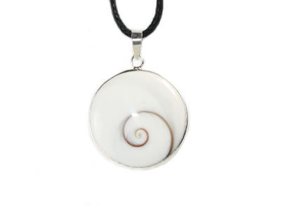
The Eye of Saint Lucia and its legend
It is the cover of a shell that can be picked up on some beaches after a big storm. The size of the lids can vary from 2 mm to 3 cm.
It was in the fourth century that the legend of Saint Lucia was born, and patron saint of the blind and electricians (Lucia in Latin = light).
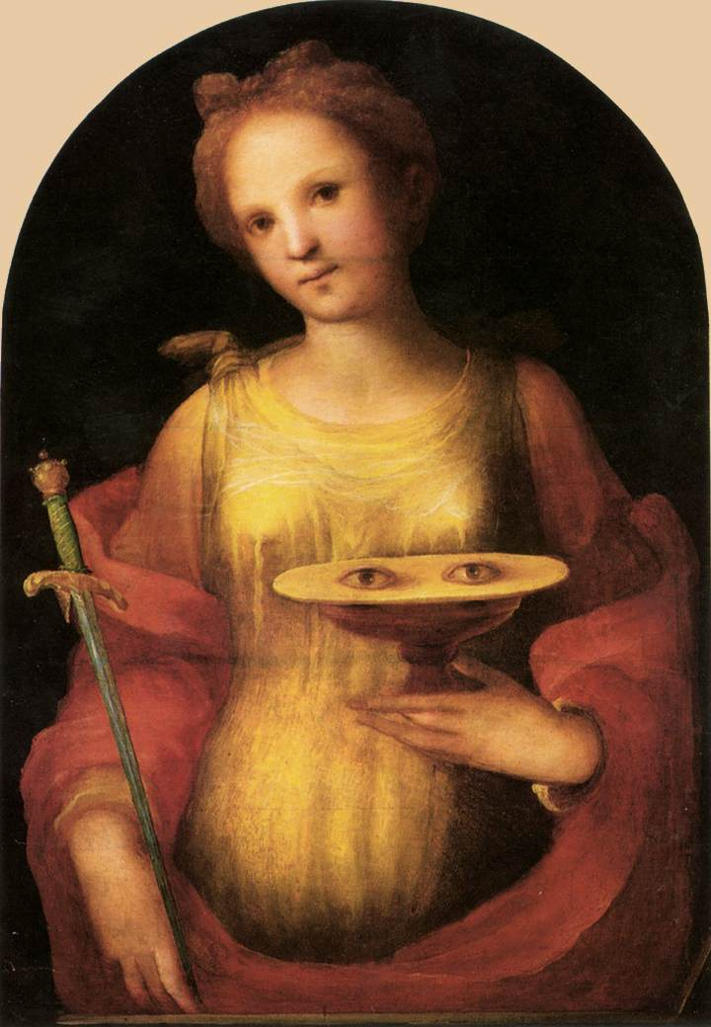
A young girl of the nobility of Syracuse obtained the miraculous healing of her mother, suffering from an incurable disease, by accompanying her to Catania to pray Saint Agatha.
Lucia asked her mother’s permission to help the poor with their money and took a vow of chastity. The fiancé seeing himself robbed went to denounce Lucia to the Roman Consul and she died in martyrdom. In the meantime, she tore her eyes out and took them to her fiancée, or, according to other legends, threw them overboard – hence the link with the shells.
According to some writings, the Blessed Virgin restored his sight and gave him more beautiful and luminous eyes (« Occhji belli e lucenti »)
The seal of the shell called the Rough Star, found on the Mediterranean shores, symbolizes the eyes of Saint Lucia. It is said that wearing a remote eye promotes bad luck.
It should be noted that variations of this symbolism can be found throughout the Mediterranean basin and beyond (especially in Indonesia).
In Corsica, the “Eye of Saint Lucia” is considered a good luck charm.
Sources :
http://fr.wikipedia.org/wiki/Oeil_de_Sainte_Lucie
http://www.scoop.it/t/bijoux-en-pierre/p/2846727141/l-oeil-de-sainte-lucie
Illustration : Dominico Beccafumi (Sienne, 1486-1551).
Culte de Sainte Lucie : http://www.introibo.fr/13-12-Ste-Lucie-vierge-et-martyre
www.scattamusica.fr
scattamusica@gmail.com
0495617734 ( international : +33495617734 )
Boîtes à musique Scatt’a Musica
20220 Pigna

